The School District of Palm Beach County took the expression, “An apple a day keeps the doctor away,” to new levels yet again. The 3-week Apple a Day program ran from October 28 through November 18 of 2015. This fourth edition exceeded all expectations and surpassed previous records.
The District hosted the Apple a Day program for the fourth year in a row as a fun and engaging way for personnel to lead healthier lifestyles– showing the District’s steadfast dedication to well-being. Participants, including teachers, staff, and administration were challenged to eat up to two apples per day, take a picture with the apple, and submit those daily photos to earn points. With participants organized into teams based on their school or department, the competition was more spirited than ever before. The 2015 Bonus Initiatives included:

- Apples & Students – Improve the wellness culture of your school/department by encouraging students to be healthy!
- Wear Pink & Eat Apples – Support breast cancer awareness and early detection.
- Apples & The Pledge – Take the American Diabetes Association pledge to beat back the increased prevalence of diabetes.
- Apples & School Spirit – Show how great your school is in a picture while eating an apple.
- Apples & Relaxation – Try taking a minimum of 15 deep breaths while enjoying an apple. Show how relaxed you can be.

Apple a Day Results
The results of Apple a Day ‘15 continue to build upon the initiatives’ previous year’s results:
- Over 8,000 people were identified eating apples or other approved fruits and vegetables.
- 239 schools/departments took part in the event.
- The number of submissions per participant steadily increased and more than 10,000 apples were consumed.
In four years, Apple a Day has gathered impressive stats:
- 53,201 pictures demonstrating better nutritional decisions have been submitted.
- 16,000+ members of the District’s community have participated.
- Over 2,000 employees have participated in at least 3 of 4 editions.
The Competition
Del Prado Elementary took the title after a hard fought battle with Melaleuca Elementary and Palm Beach Public. Environmental Conservation Services and Equestrian Trails Elementary rounded out the Top 5 Teams. Del Prado joins the elite group of champions, including Intensive Transition South (‘12), Palm Beach Central High School (‘13) and Palm Beach Public (‘14).

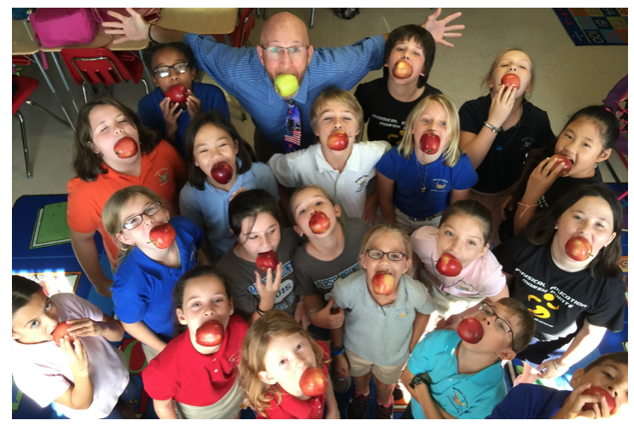

The 2015 MVP was Mr. J.P. Hauser of Marsh Point Elementary. Five other participants were tied with Mr. Hauser atop the Honor Roll upon conclusion of Week #3; however, the tie fell by popular vote in this year’s Top Pic(k) Contest, where Mr. Hauser’s healthy display of creativity and ingenuity (pictured above) was resoundingly appl(e)auded.

