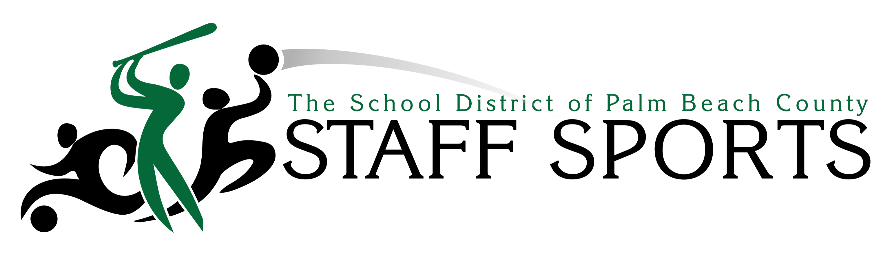

The Staff Sports Program is the latest, District-wide initiative to be incorporated into The Wellness Program. The objective is to offer all personnel members with greater opportunities to move more in a fun, competitive team atmosphere. Physical activity is essential to overall health and well-being, and the District is always looking for better ways to encourage this.

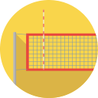

During its inaugural year (2015-’16), the Staff Sports Program was comprised of both Fall and Spring Leagues. Fall sports included Kickball, Soccer and Volleyball while spring sports included Basketball, Tennis, and Softball. Teams were formed within the vicinities of where participants work and/or live. League divisions and games were scheduled to keep travel time to a minimum. Games lasted up to 1 hour, but many teams continued to play on for practice and fun. Each League featured intense playoffs with the 5 teams taking home titles.

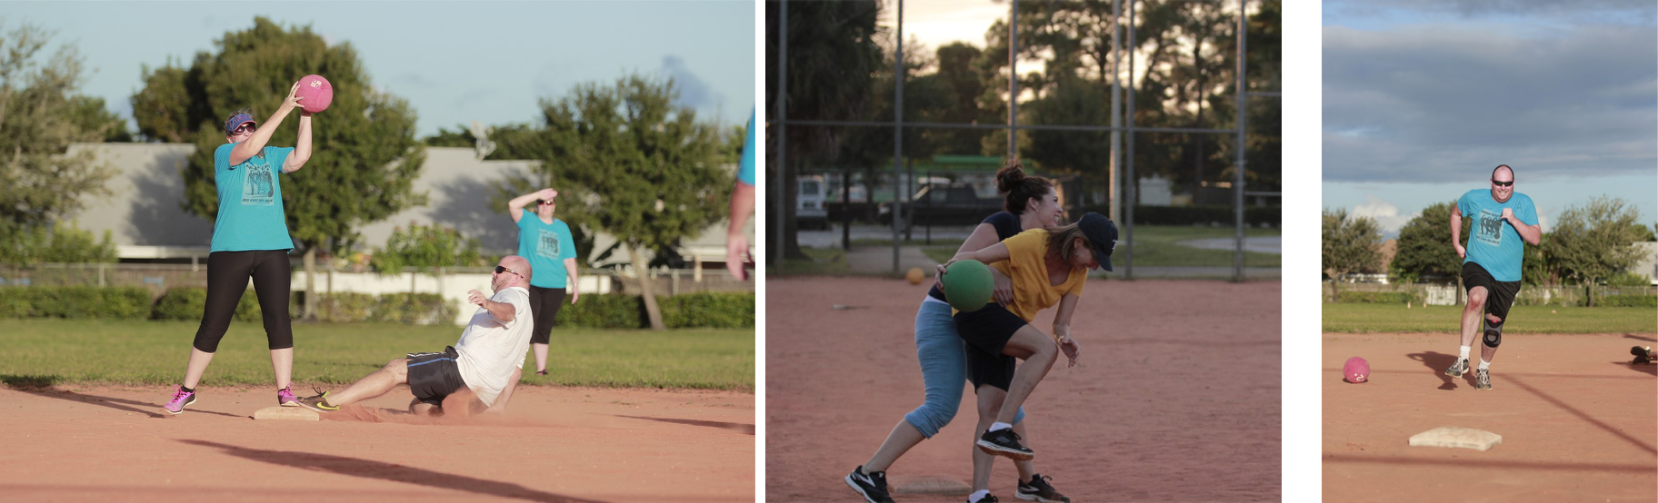

Staff Sports Results:
- 1,528 employees participated
- 120 teams were formed, representing 100+ locations
- 357 games played (approximately 4,998 hours of physical activity combined)

Winning Records:
- Kickball Champions – 2 Legit to Kick, Amy Kolodny (C) of L.C. Swain Middle
- Soccer Champions – Vikings , Andrew Buck (C) of Verde Elementary
- Volleyball Champions – Polo Park Unforgetables, Michael Combs (c) of Polo Park Middle
- Softball Champions –Panthers, Bruce Saulter (c) of Seminole Trails Elementary
- Basketball Champions – Dolphins, Tashina Bailey (c) of Pine Grove Elementary

